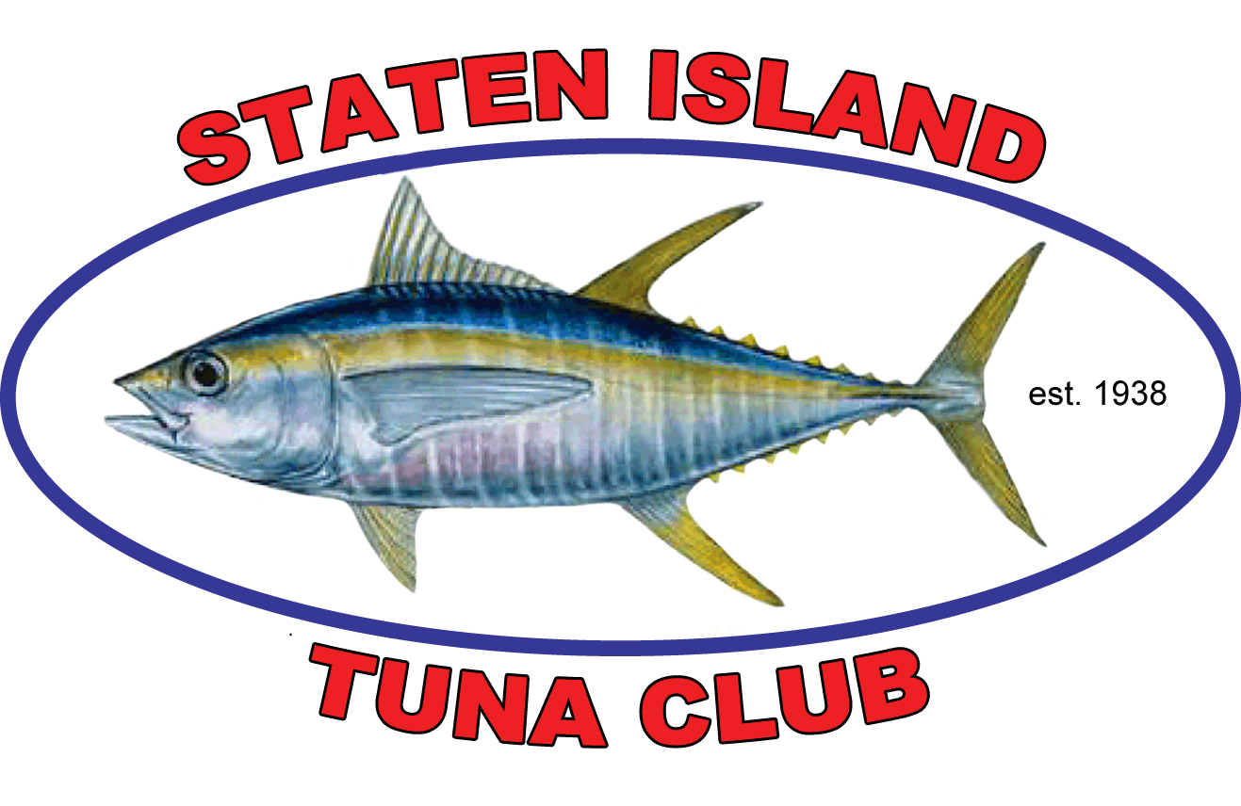 Staten Island Tuna Club – Scholarship Application
============================================================================================================================================
SCHOLARSHIP OPPORTUNITY
ACADEMIC ADVISORS AND/OR GUIDANCE COUNSELORS PLEASE POST AND DIRECT TO ALL ELIGIBLE STUDENTS

Established in 1938, the Staten Island Tuna Club has been giving back to the community in many ways. It brings together the strength and talents of fisherman with each other as well as their families and the community. The mission of the Staten Island Tuna Club is to plan and promote fishing and fisheries that unite fishermen within this country.

Since its inception the Staten Island Tuna Club has placed special focus on volunteerism and educational excellence as the key to the future of the fishing community. To this end, in September of 2014, in celebration of the 76th anniversary of the Staten Island Tuna Club, the John Haugen Scholarship Awards Program was established. This year was the beginning of the fund and once the fund reaches maturity, the Staten Island Tuna Club will award $2,000 scholarships to exceptional fishermen youth who are making a difference in their community. All applications must be mailed via regular Post Office to Christopher Beinert, Chair Scholarship Committee @ 344 Douglas Road, Staten Island, NY 10304. Overnight, Express or Return Receipt applications will not be accepted. Any questions or concerns may be directed to Mr. Beinert who can be reached telephonically (973) 634-7764 or via e-mail at cbeinert@msn.com.

ELIGIBILITY

Applicants must be of members of relative of Staten Island Tuna Club members or past members.
Applicants must have a resume of volunteer community service experience.
Applicants must be enrolled in a full time undergraduate degree program in an accredited college or university upon receipt of the award.
Applicants must have a minimum Grade Point Average (G.P.A.) of 3.0 or better.
Applicants must undergo a face to face interview with the Selection Committee (Exigent circumstances must be discussed with Chris Beinert).

GUIDELINES

A completed application package must include an application form, essay, a biographical sketch, Volunteer Community Service Statement, two letters of recommendation of which one letter of recommendation must be from the site where the student performs his/her volunteer work, academic transcripts (for College Students), SAT scores and Transcripts or last Report Card (for High School Students), and Head Shot Photo. All items must be submitted in one package.

Letters of recommendation should be requested from teachers, counselors, mentors, clergy, community leaders, etc. The letters should highlight the applicant’s volunteer community service, how long has the person known the candidate, and the specific contributions the applicant has made to the community.

Application packages postmarked after the postmark date will be disqualified. Applicants who will be invited for an interview will be notified by mail by. Recipients of the Staten Island Tuna Club Scholarship will be disqualified should any of the following conditions occur: (1) recipient provides false information on application; (2) recipient fails to graduate from High School by June; (3) recipient is not enrolled in an accredited college or university by the fall and (4) recipient is not a relative of the Staten Island Tuna Club.

Scholarship payment will made by the Staten Island Tuna Club at a time determined by the committee and only upon receipt of official college registration and other requested documentation.
APPLICATION PACKAGE MUST INCLUDE THE FOLLOWING ITEMS: Failure to provide any of these items application will disqualify applicant.

High School Applicants Undergraduate Applicants Only

- High School transcripts or last report card College transcripts
- Two letters of recommendation Two letters of recommendation
- Essay Essay
- Community Service Statement Community Service Statement
- Head Shot Photo Head Shot Photo
- Sat Score

Christopher Beinert – Chairperson
Walter E. Fisher, Jr. – Co-Chair Scholarship Committee
SCHOLARSHIP COMMITTEE: c/o Christopher Beinert ♦ 344 Douglas Road, Staten Island, NY 10304 ♦ Phone: (993) 634-7764 ♦ e-mail: cbeinert@msn.com

Staten Island Tuna Club – Scholarship Application
============================================================================================================================================
2009 APPLICATION MUST BE POSTMARKED NO LATER THAN JANUARY 15
(NO EXPESS, OVERNIGHT MAIL OR RETURN RECEIPT MAIL ACCEPTED- PLEASE SEND VIA REGULAR MAIL)

Name: ______________________________________________________________________________________________________
Address______________________________________________________________________________________
Phone#: ______________________________ Cell #:_________________________________________

E-Mail: _______________________________ Social Security Number: __________________________ Attach passport

Mother’s Name: ________________________Occupation: ____________________________________ size photo here
Father’s Name: ________________________ Occupation: ____________________________________

ACADEMIC INFORMATION:

HIGH SCHOOL STUDENTS

High School: ___________________________________ Telephone # __________________________ Fax#: _____________________
Address: ______________________________________________________________________________________________________
Guidance Counselor: ____________________________________________________________________________________________
Grade Point Average: ____________ SAT SCORE: _________ List other awards:
List other scholarships applied for: Do you plan to apply for financial aid?
List Colleges and Universities you are applying for:
===============================================================================================================

COLLEGE/UNIVERSITY STUDENTS:

College/University: ____________________________ Telephone #: _______________________ Fax#: ________________
Address: _____________________________________________________________________________________________
Advisor: ________________________________________ G.P.A. ________ Major: ________________________________
Anticipated date of graduation: ______________________ Residence: On-Campus ____ Off-Campus
Do you receive Financial Aid? ___________ List other scholarships:
List any awards received

ESSAY: In your opinion what is the most important issue affecting the fishing or fisheries Community today? State how you would address the issue as a leader in the community. Give examples of how you would resolve this situation. What would your role be? Explain why your recommendations would be successful.

BIOGRAPHICAL SKETCH: In 500 words tell us about yourself. Include your interests, goals, dreams, career objectives, etc.

COMMUNTIY SERVICE STATEMENT: List any volunteer community work you have participated in which involved the community/fishing community. Describe your activities. Discuss when, why and how you became involved in each community service initiative. Describe how this community service impacts the Fishing Community.

ATTACH TWO LETTERS OF RECOMMENDATION one of which is directly from one of your community service sites.

I the undersigned do fully agree and comply with the requirements and rules as stated herein by the committee – Staten Island Tuna Club Scholarship Award Program. I attest that the information provided herein by me, the undersigned, is true and accurate and further understand that if the information proves to be inaccurate or false, it will serve as grounds for immediate disqualification.

Signature and Date: ___________________________________________________________________________________________________

Christopher Beinert – Chairperson
Walter E. Fisher, Jr. – Co-Chair Scholarship Committee
SCHOLARSHIP COMMITTEE: c/o Christopher Beinert ♦ 344 Douglas Road, Staten Island, NY 10304 ♦ Phone: (993) 634-7764 ♦ e-mail: cbeinert@msn.com

